Exercise 4. Starting Wallace and Loading Occurrences

|  |  |
| --- | --- |
| Skills Acquired | Data Required |
| * Launching of ecological niche modelling software in an R environment | * A dataset that has been processed for ecological niche modelling |

# 

Step 1: Starting Wallace

First thing’s first. We’ll start by launching Wallace and giving you a quick overview of the steps you will go through to generate a niche model today.

# *Launch RStudio.*

RStudio is a helpful platform for writing and executing R code. You can write and save scripts, execute commands, and keep track of datafiles. We don’t have time to give you an exhaustive overview of all the RStudio features, but if you are curious, check out the link at the end of this exercise. For our purposes, the important thing for you to know is that there are four panes in RStudio, as follows (note that depending on your operating system and the version of RStudio, it may not appear exactly identical):

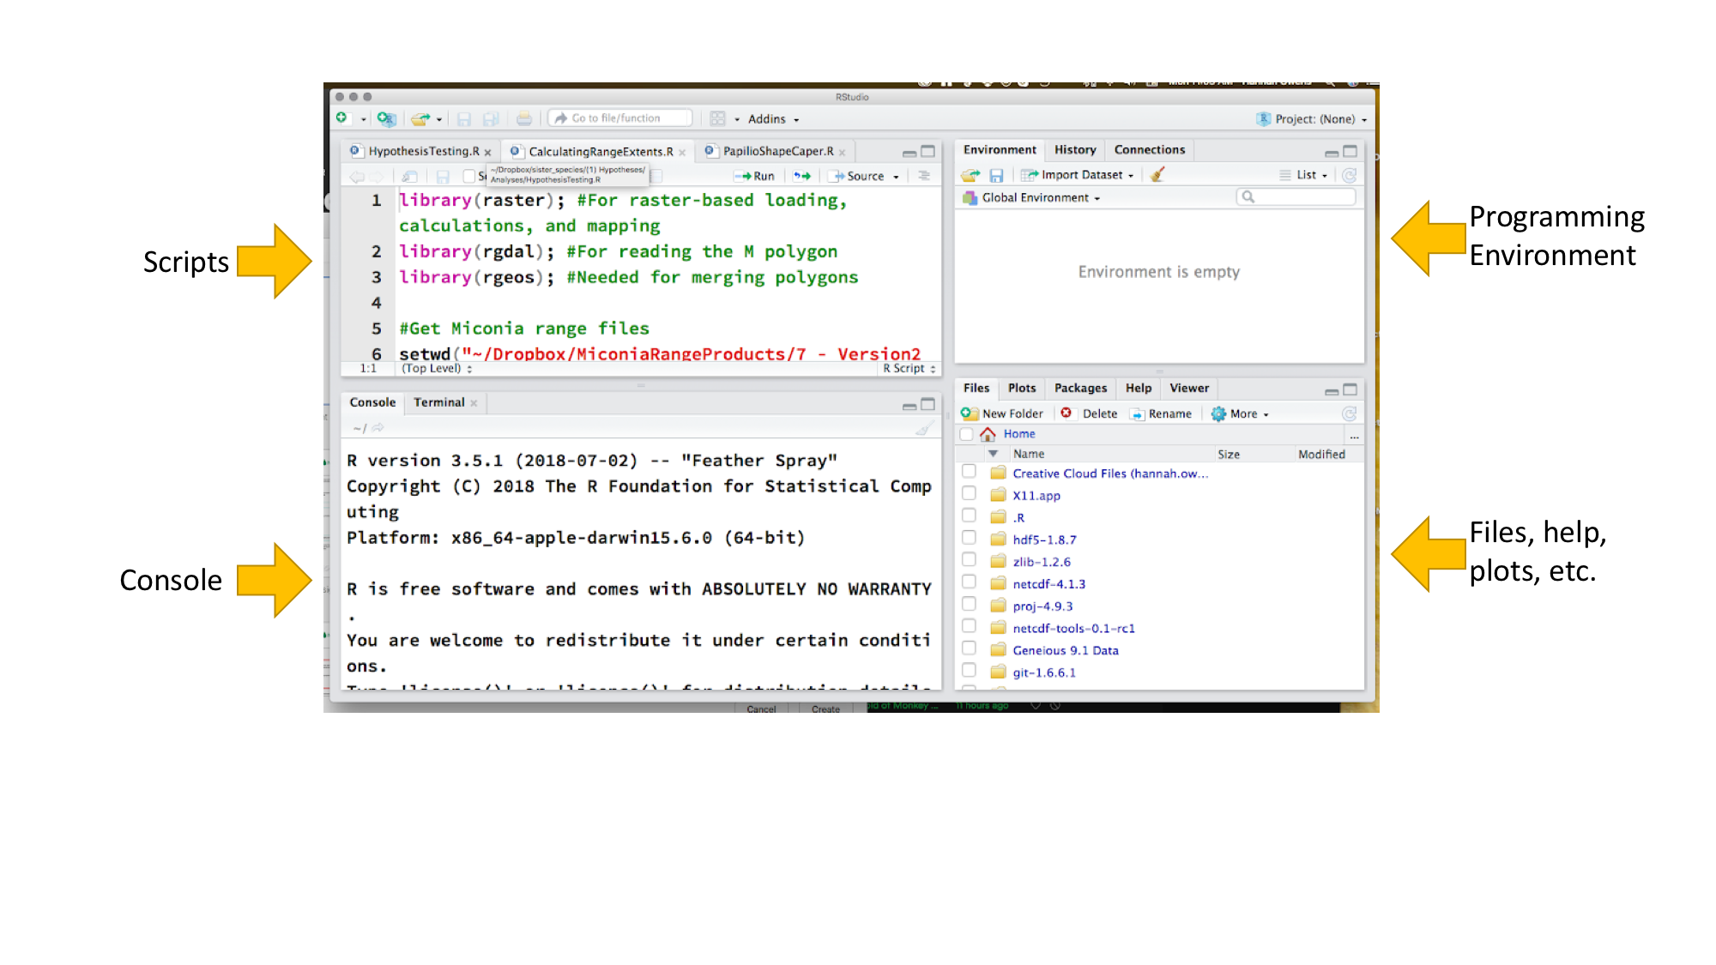

* *Launch Wallace*

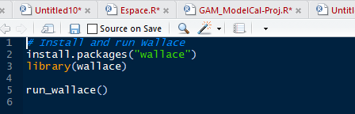

1. If you have installed Wallace, proceed to step b. If you have not installed Wallace, type the following in the console window of RStudio and hit “Enter”:

install.packages(“wallace”);

1. Type the following in console window of RStudio and hit “Enter”:

library(“wallace”);

1. Type the following in console window of RStudio and hit “Enter”:

run_wallace();

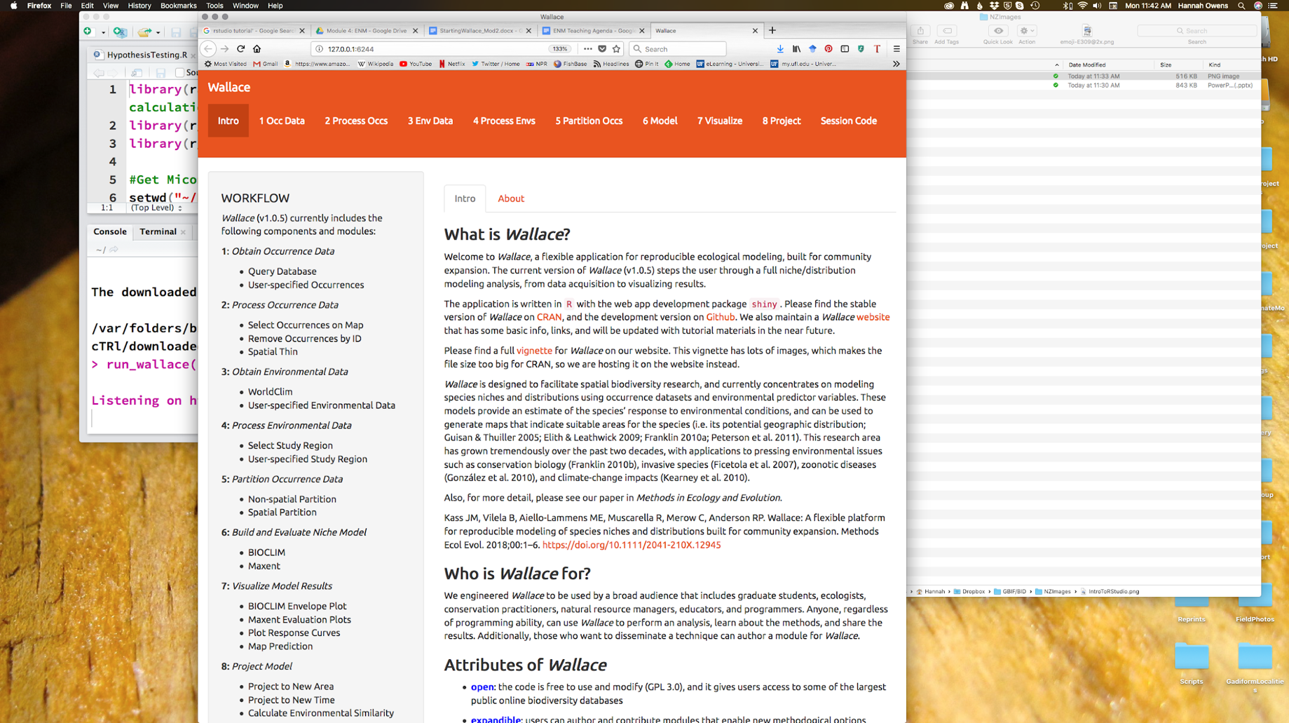This should launch Wallace in an internet browser window.

Along the top of the browser is a menu bar with each of the steps that go into generating a niche model. You can also see this as a workflow in the left-hand panel. We will follow the general outline of this workflow, but with some slight modification. This will bel explained more as we work through generating our own niche models today.

Step 2. Loading occurrence points.

There are two options for loading occurrence data in Wallace. The first option is to directly query several biodiversity databases including GBIF. This is good for generating quick and dirty niche models to explore data, but Wallace does not allow you to clean data in all the ways we discussed yesterday as best-practices. For this reason, you will load in the occurrence points you cleaned yesterday. This is also good to know if you have your own occurrence data that is not yet served through a database connected to Wallace.

1. Click on “1 Occ Data” in the menu bar at the top of the Wallace window.

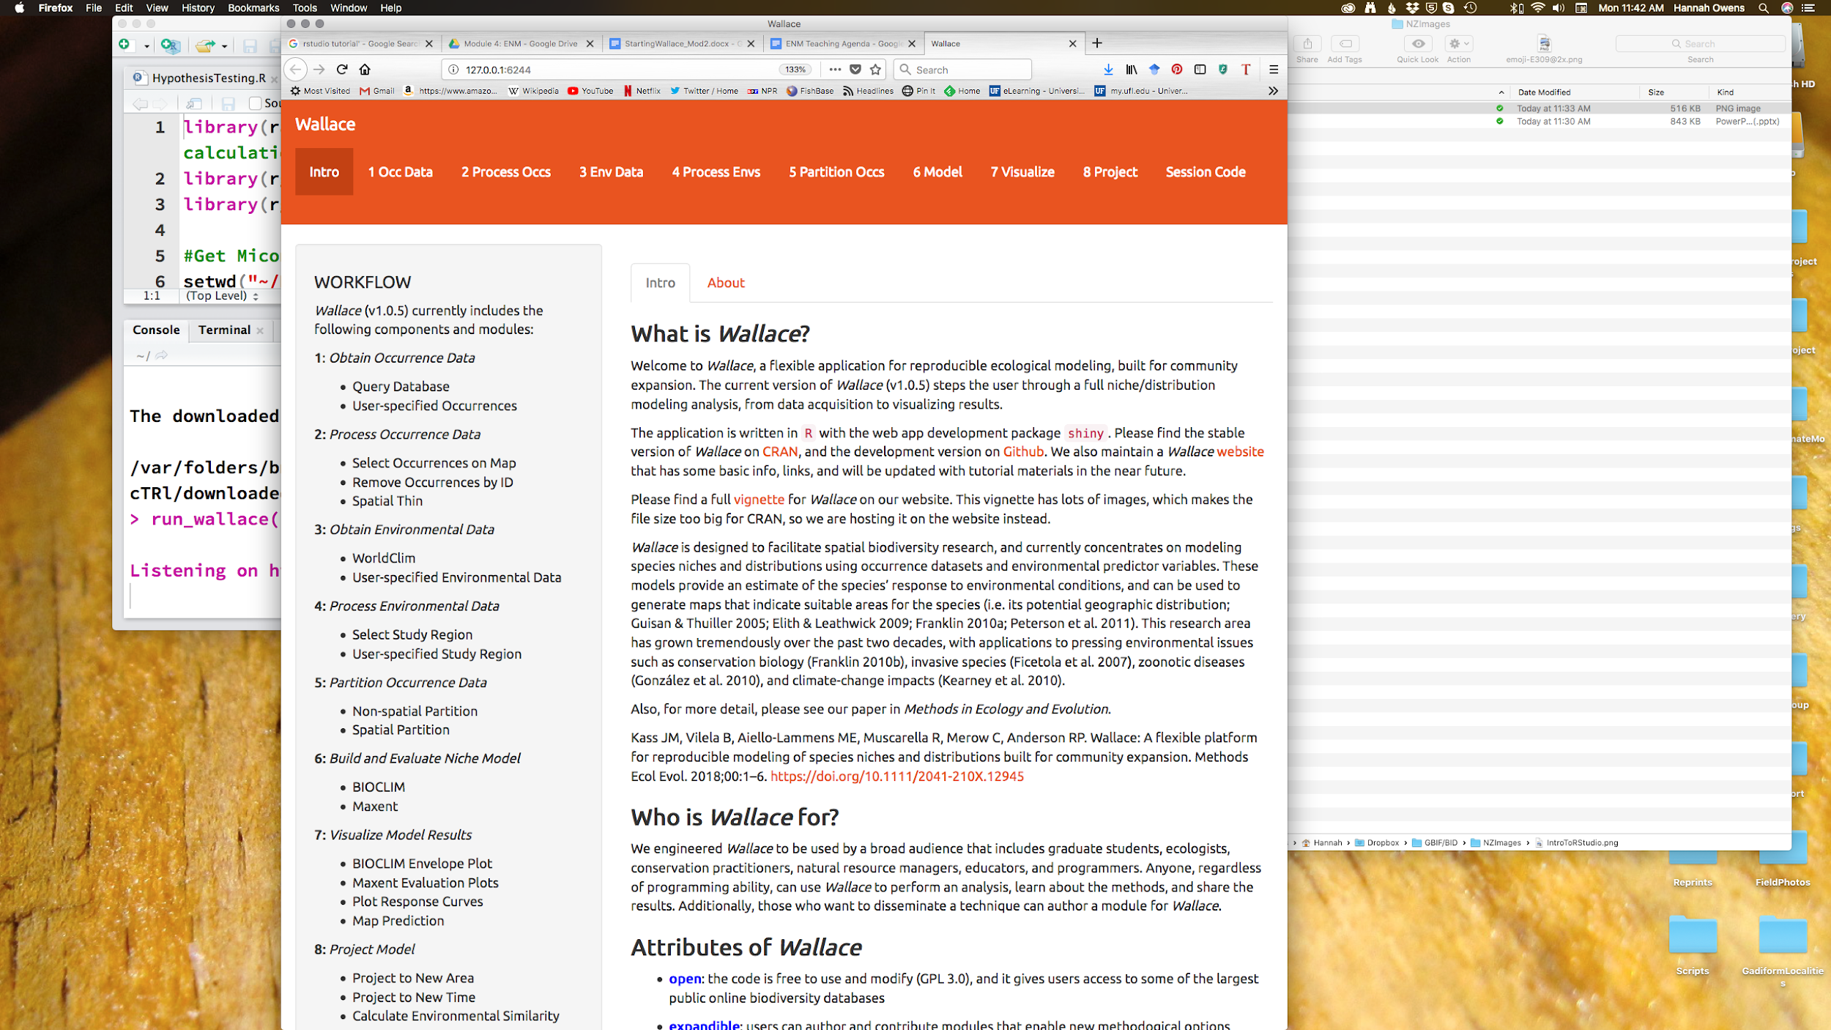

b) In the panel on the left, select the “user specified” radio button.

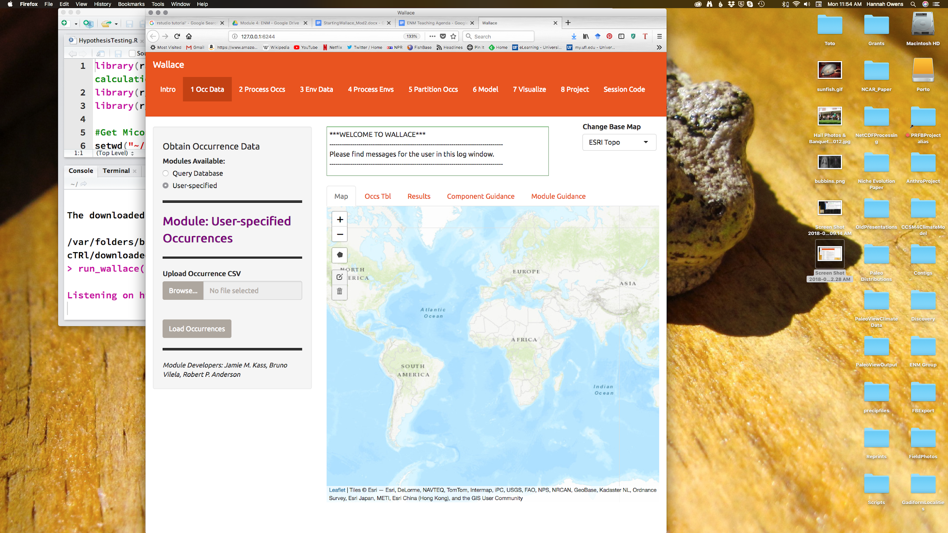



Notes on the Wallace interface:

* As we begin importing and processing data, a detailed record of what has been done will be recorded in the log window above the map.
* If you need a refresher on the background of a particular modeling step, you can click on the “Component Guidance” tab
* If you need help understanding the elements of a particular modeling step, you can click on the “Module Guidance”.

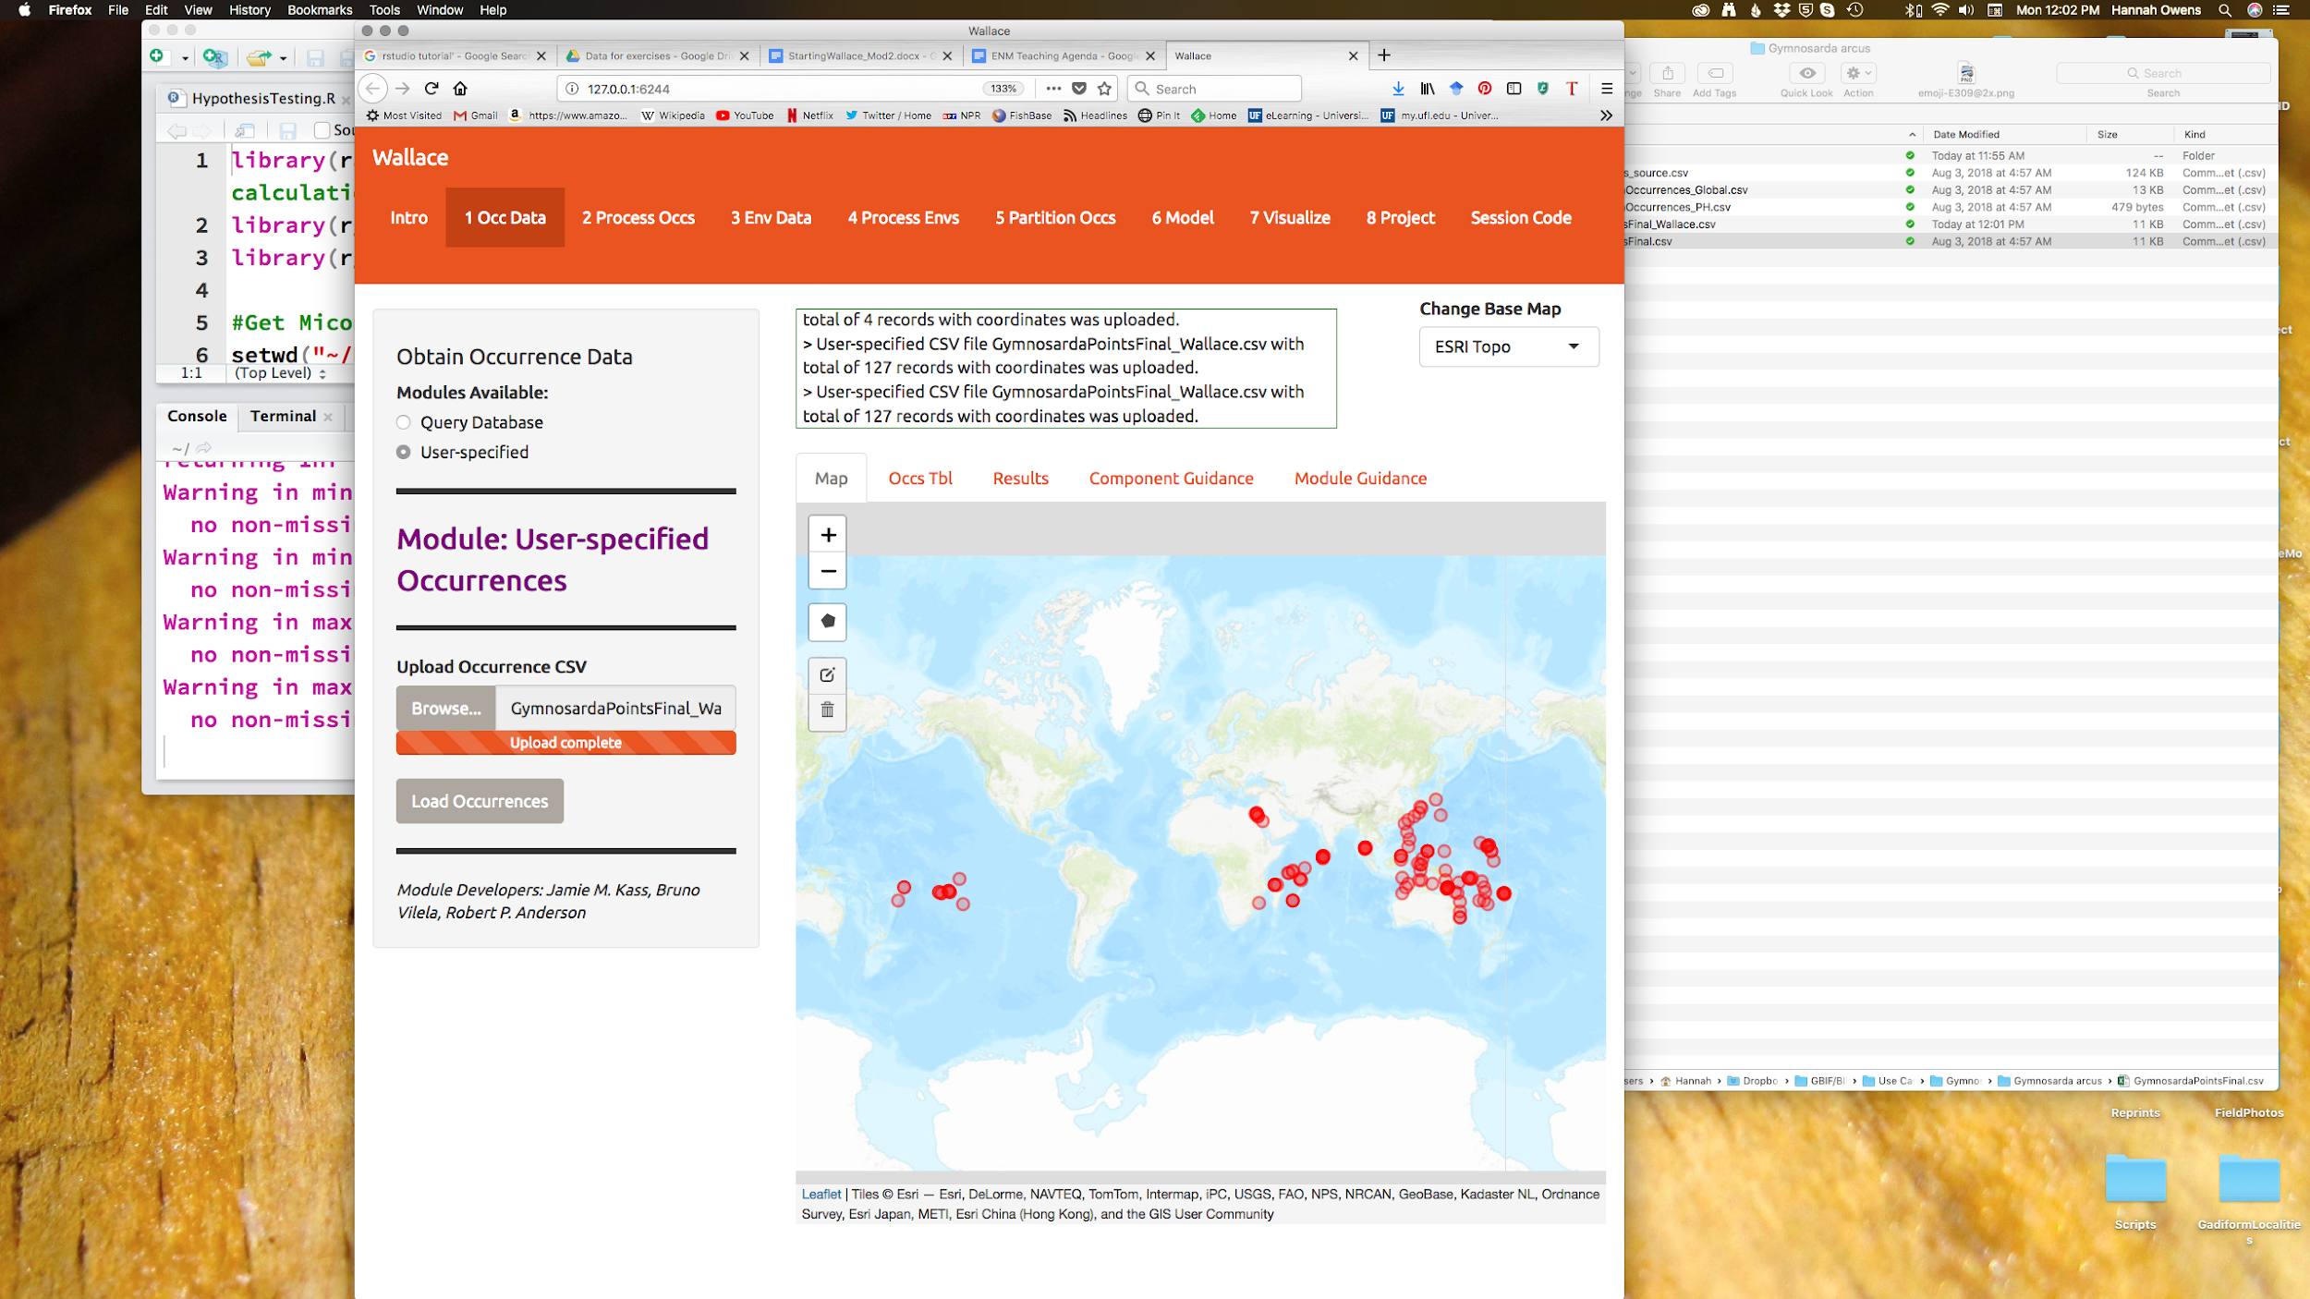c) Click browse, locate your file entitled “GymnosardaPointsFinalWallace.csv”, and hit “open”. After a few seconds, you should see an orange bar under the “Browse” button that says “Upload Complete”.

d) Click “Load Occurrences” under the “Upload complete” bar. Your occurrence points should all show up as red dots on the map.



Note: You can interactively explore your points by clicking on them on the map (see below). You should see all the information associated with that record from the table you uploaded. This is helpful for verifying your occurrence points before progressing through the workflow.

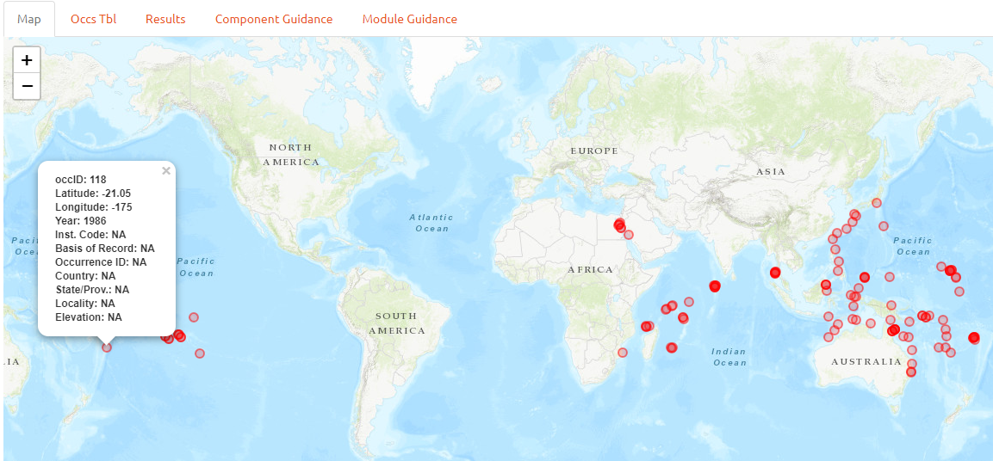

**Link for more information:**

R programming and R studio: <https://www.rstudio.com/online-learning/>